Southern Asset Management Limited is committed to leading the industry in minimising the impact of its activities on the environment.
The key points of its strategy to achieve this are:
- Minimise waste by evaluating operations and ensuring they are as efficient as possible.
- Minimise toxic emissions through the selection and use of its fleet and the source of its power requirement.
- Actively promote recycling both internally and amongst its customers and suppliers.
- Source and promote a product range to minimise the environmental impact of both production and distribution.
- Meet or exceed all the environmental legislation that relates to the Company.
- Use an accredited program to offset the greenhouse gas emissions generated by our activities.

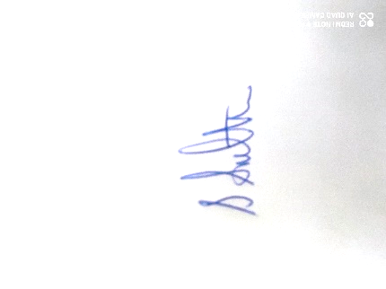
POLICY OWNER: Stephen Southern- CEO

SIGNATURE:

DATE: November 2024

POLICY REVIEW DATE: November 2025

